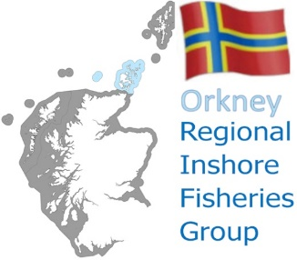

**Orkney Regional Inshore Fisheries Group**

General Meeting: 7.30pm Tuesday 30 January 2024

**AGENDA**

1. Welcome and Introductions
2. Apologies
3. Minutes from the meeting held on 26/09/2023
4. Matters arising
5. -
6. -
7. -
8. -
9. -
10. -
11. RIFG Chair Update
12. Proposed new training requirements (M Shiner)
13. West of Orkney Windfarm Update & Questions (J Farnham)
14. Any Other Business
15. Next meeting
16. Close

Contact details for Phil

|  |  |  |  |  |  |
| --- | --- | --- | --- | --- | --- |
|  | 07305 212429 |  | [orkneyrifg@gmail.com](mailto:orkneyrifg@gmail.com) |  | <https://rifg.scot/> |